
ОБЩЕСТВО С ОГРАНИЧЕННОЙ ОТВЕТСТВЕННОСТЬЮ
«ЛАЗЕРТАГ»

ПАСПОРТ

Смоленск
LIMITED LIABILITY COMPANY
LASERWAR

SPECIFICATION

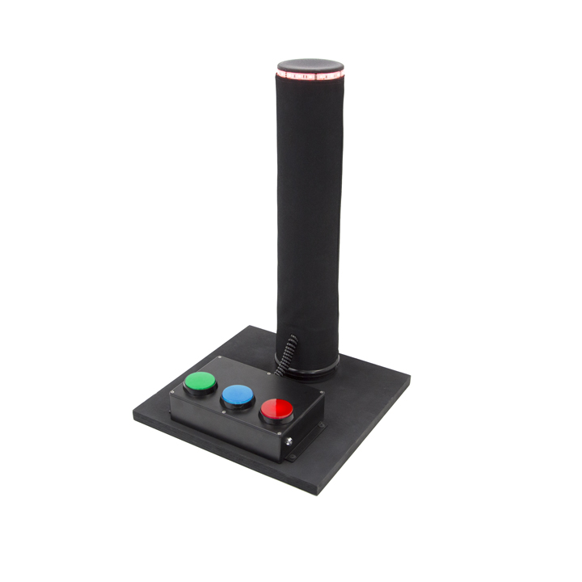
Game set

BATTLEFIELD PRO

Dear Customer!

Our company welcomes and thanks you for the decision to buy our products, and is confident that the purchased device will bring you a long-term pleasure. The warranty certificate establishes the guarantee of the product in the amount provided for by the Law on consumer protection of the Russian Federation.
This warranty certificate is valid for 12 months from the purchase date of the product, and is subject to the guarantee terms.
Warranty Terms:
1. The guarantee is effective upon presentation of this coupon, which shall contain the serial number of the product and the date of its purchase, confirmed by the service centre.
2. These guarantee obligations apply to products acquired only from the official LASERTAG representative or the official dealer.
3. The present guarantee is invalid if the product deficiencies have occurred in the following cases:
- failure to comply with Operating instructions;
- mechanical damage;
- penetration of extraneous items, liquids, etc.;
- animal activities;
- unauthorized access to the parts of the game set by non-authorized persons;
- use of the product for purposes for which it hasn't been made;
- Acts of elements (natural disaster, fire, accidents, etc.);
- the game set malfunction in case of faulty power network and/or poor care of the product.
4. If the warranty certificate is lost, no duplicate is issued.

9. Contact information

Official website:
www.laserwar.com

E-mail: Purchase Date: _________________________
info@laserwar.com
help@laserwar.com

Skype:
info@laserwar.com
help@laserwar.com

______________________________________
signature

2
7
1. Description
The BATTLEFIELD PRO game set is an additional game device that can be used in different game scenarios.
2. Scope of application
The device is designed for laser tag scenarios that include the capture of the control point. The game set is used in organizing sporting events, tactical exercises, corporate and recreational activities.

3. Contents of delivery:
- The BATTLEFIELD PRO game set - 1 pcs.
- Specification - 1 pcs.

4. Basic technical Data
Height, mm | 580
Diameter of the pipe, mm | 105
Base length and width, mm | 380
Battery type | Lead acid
Capacity and rated voltage | 1200 mAh, 12V
Battery charger type | Sonar
Number of colors displayed in the game (red, blue, green) | 3
Weight, kg | 4.8

5. The device
The BATTLEFIELD PRO consists of a black plastic pipe, a base, one RGB-strip of different colors, power button and 3 buttons used for capturing the control point.
Inside the frame there are batteries, clamping elements as well as a sound module.

Information on the repairs performed during the maintenance period (completed by the Service centre performing the warranty repair works).

Date: __________________  Completed work: _____________________________________________________________________  Service centre stamp | Date: __________________  Completed work: _____________________________________________________________________  Service centre stamp
Date: __________________  Completed work: _____________________________________________________________________  Service centre stamp | Date: __________________  Completed work: _____________________________________________________________________  Service centre stamp
Date: __________________  Completed work: _____________________________________________________________________  Service centre stamp | Date: __________________  Completed work: _____________________________________________________________________  Service centre stamp

3
6
6. Maintenance
All parts of the set must be treated with care if you want the equipment to function properly. There shouldn't be any moisture inside the frame. Charge the battery when needed. Recharge the set using a battery charger (the charger is not included in the set, in should be purchased separately). Don't hit the device.

7. User's manual
The BATTLEFIELD PRO is used for capturing key points. It is a universal device and can be used not only in laser tag, paintball and airsoft scenarios. At the start of the game, the point is neutral. To capture it, you must press the button painted in the color of your team. The device will light up in the right color. The color will gradually gain brightness and saturation. To capture your opponent's control point, the team must press the button of its color. Gradually the new color will "displace" the previous one. The team that first holds the device for the set amount of time wins.

8. Changing characteristics
You can change the set amount of time if you hold the red button during the system start up. Then we can choose the mode by pressing the buttons.
Red - 5 minutes
Yellow - 10 minutes
Green - 15 minutes
Light blue - 20 minutes
Dark blue- 30 minutes
Pink - 60 minutes
White - 120 minutes.
If you hold the blue button during the system start up, you can choose the time during which you must hold the button to capture the device (green -10 seconds, blue - 20 seconds, red- 30 seconds). The device will save the settings and go into the main mode in 10 seconds.

Equipment Maintenance Rules
1. Weather conditions. At the course of manufacture, we make different tests to see how well the equipment works under different weather conditions. Despite this, we strongly recommend that the equipment shouldn’t be used in the rain and at temperatures below -20 ° C.
What should I know when using the equipment in poor weather conditions?
The most important thing is to avoid getting moisture inside the device. If this happened, turn off the device, dry the equipment at room temperature for at least two hours.

2. Power source. The device uses 12V lead acid batteries.
To recharge the device use only "Sonar" chargers.
Charge the device under supervision for three hours.

It is necessary to store the equipment in a well-ventilated room at temperature from + 18°C to + 30°C and relative humidity of 45-65%.
The warranty is 14 days for batteries, speakers, and IR modules. These components are expendable materials.

PLEASE NOTE! In the case of improper operation of the accumulator (charging by an unrelated type of a charger), the warranty doesn't cover the battery!
4
5

